Ex.1 create your first commit.

Initialize your repository: git init

Create file: touch index.html

Write code

Stage: git add

Git commit: git commit -m “initial message”

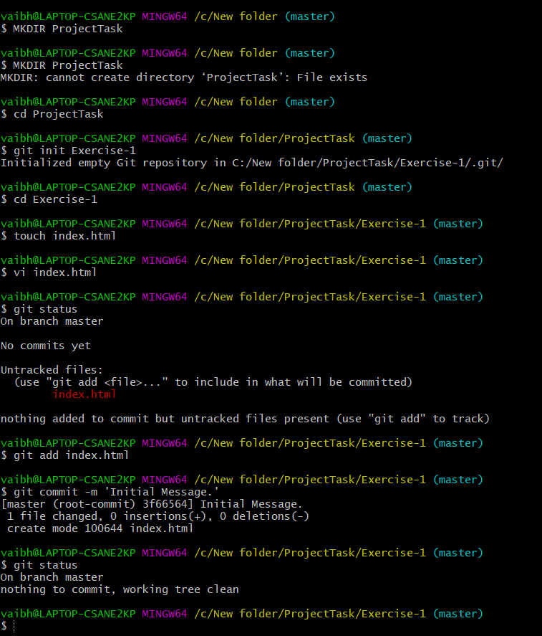

Ex.2 Commit only one file.

Task

Initialize your Repository: git init Exercise-2

Create a files with names index.html and about.html

Add code in both files.

Stage only one file.

Commit with message: ‘File x added.’

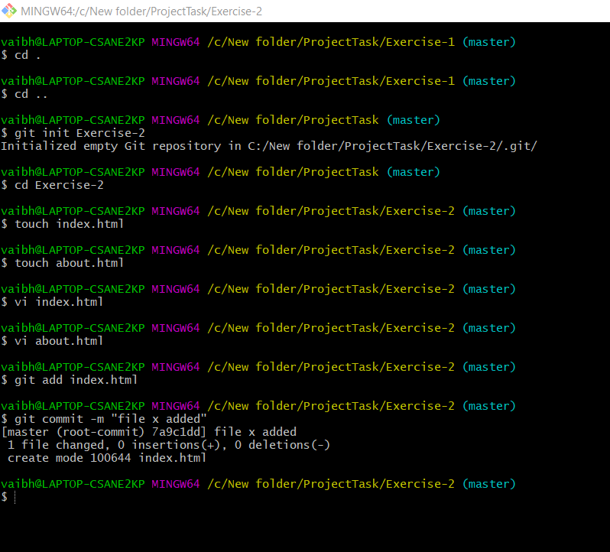

Exercise 3: Modify last commit.

Task:

Initialize your Repository: git init project Exercise-3

Create a file with name index.html

Write code in newly created file

Stage index.html

Commit with message ‘adding index.html.’

Add new about.html file with some code.

Now modify message of previous commit as ‘Adding index.html and

about.html ’and add about.html file in previous commit.

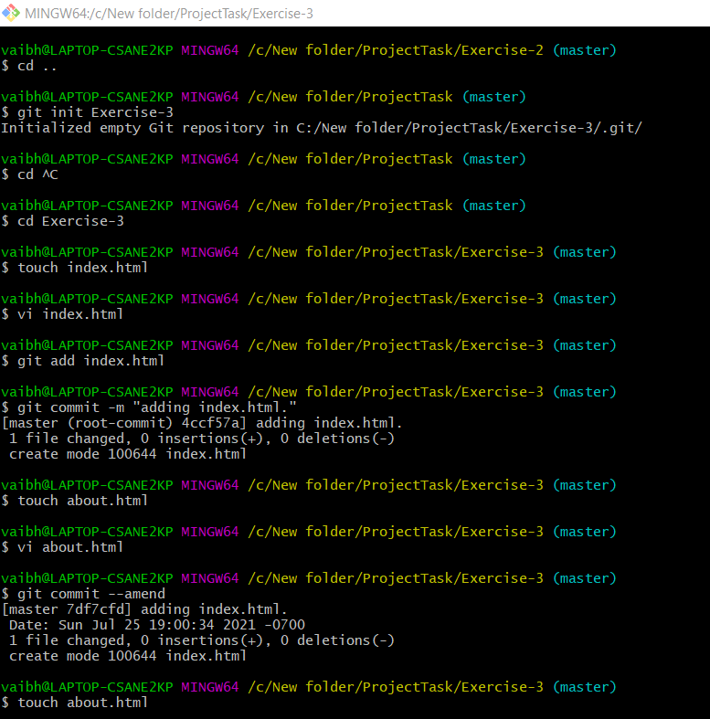

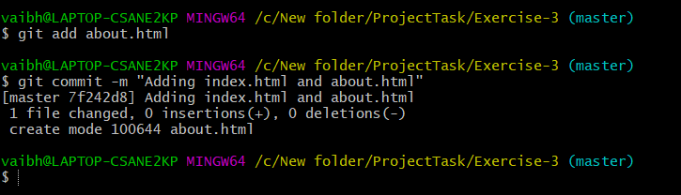

Exercise 4: create git ignore file.

Task:

Initialize your Repository: git init Exercise-4

Create a git ignore file that will ignore

all files with ‘exe’ extension

all files with ‘o’ extension

all files with ‘jar’ extension

the whole libraries directory

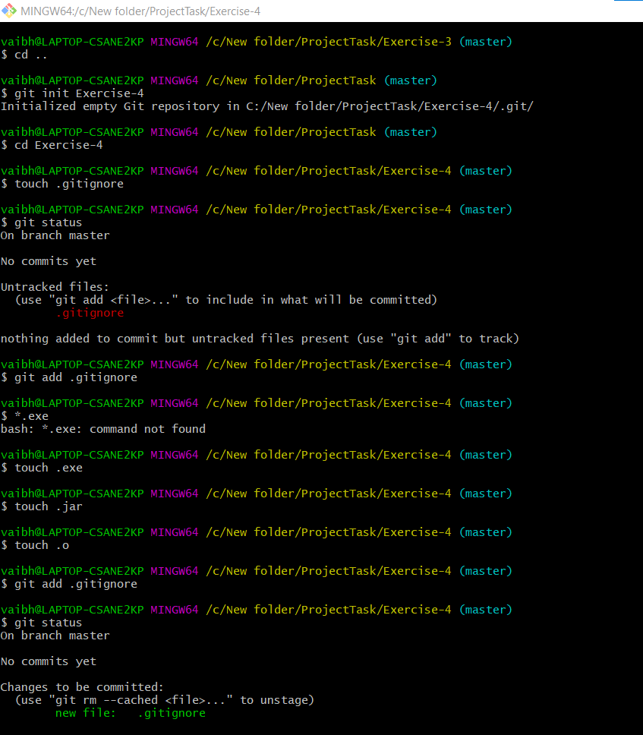

Exercise 5 - Save your work with stash

Initialize your Repository: git init Exercise-5

Add some random files with code

Now use git stash command to save required files from above files.

Exercise 5: Save your work with stash.

Task:

(For this exercise don’t send repository just submit git commands and output of

git stash list)

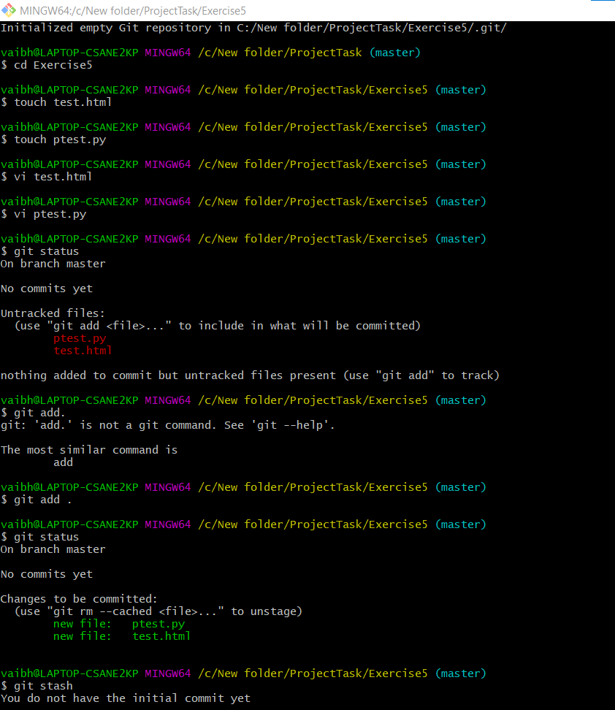

Exercise 6. 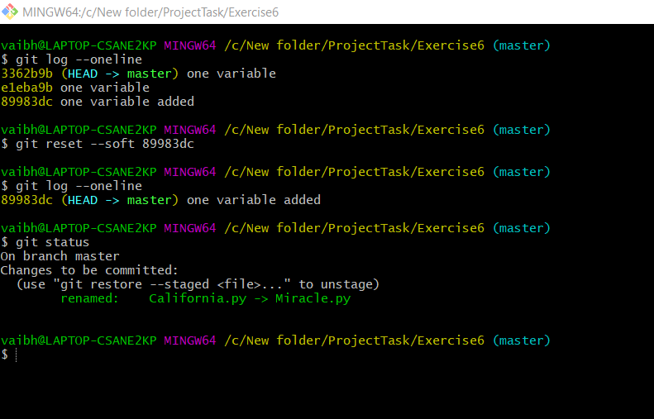

Exercise 7: Reset Previous Commit (Hard Reset).

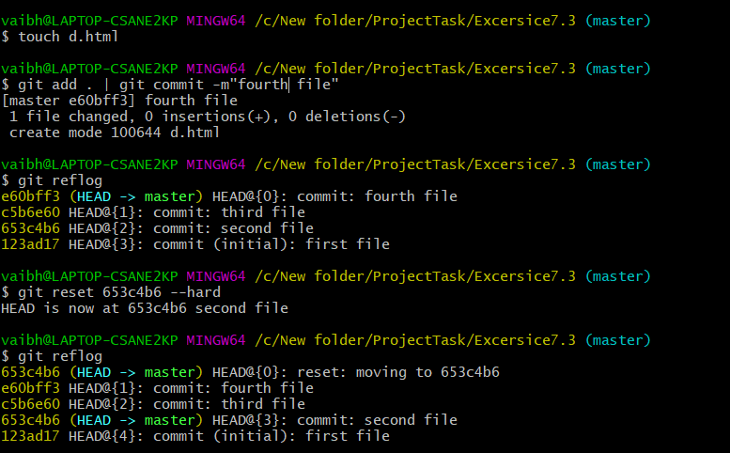

Exercise 8: Merge branch (No Conflicts).

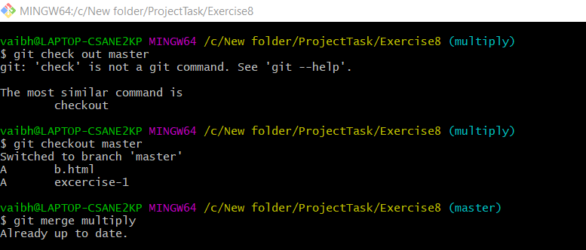

Exercise 9. Merge Branch (conflicts)

